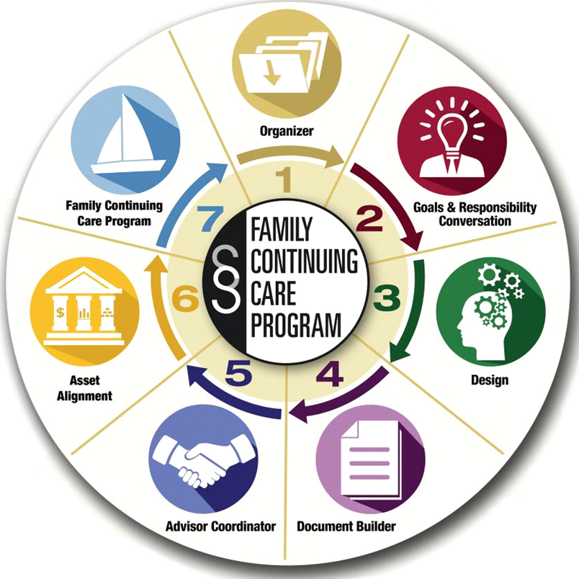

Confidential Estate Planning Questionnaire
We realize this is an extensive Questionnaire, but please provide as much information as you can so we can maximize our time together. Experience has shown us that the more information you provide upfront, the more we will be able to explore your unique concerns in order to craft solutions to address them.

Preferred mode of Contact from our office __ Email __ Phone __ Home Address
Client #1’s Legal Name ___________________________________________________________
Also Known As __________________________________________________________________
Prefer to be called _________________________________ Birth Date _______________________________
Home Address _________________________________ City __________ State ____ Zip ________________
Home Phone ________________ Mobile Phone _______________ Work Phone _____________________
Email ____________________________ SS# _____________________ U.S. Citizen? __ Yes __ No
Employer _________________________________ Position ________________________________________
Business Address ____________________________________________________________________________
City __________________________________________ State ___________________ Zip _________________
Marital Status: ___ Married ___ Single ___ Life Partner ___ Divorced ___ Widowed

Client #2’s Legal Name ____________________________________________________________________
Also Known as ______________________________________________________________________________
Preferred to be called _____________________________ Birth Date _____________________________
Home Address ______________________________ City ____________ State ______ Zip ______________
Home Phone _________________ Mobile Phone ________________ Work Phone ___________________
Email ___________________________ SS# _______________________ U.S. Citizen? ____ Yes __No
Employer _______________________________ Position ______________________________
Business Address ______________________________ City ____________ State _____ Zip ____________
If either person has been divorced or widowed, please let us know, any details that would be relevant to your future estate plan, such as children from a prior marriage.
BENEFICIARIES
Identify all potential individual beneficiaries of your estate. Children and grandchildren are most common, but you may have other individuals in your life who you may wish to be a beneficiary of your estate. Use “JT” if both spouses are parents, “Y “if you are the parent, “S “if your spouse is the parent. Please provide their full legal names, last known city, and date of birth. Use additional pages if necessary.
Beneficiary 1 Full Legal Name: ____________________________________________________
Relationship to Client: _______________ Location (City, State): _____________ D.O.B ________
__ Married __ Divorced __ Single Special Needs: ___Medical ___ Educational ___ Financial
Spouse’s Name ____________________ Occupation ________________________
Beneficiary 2 Full Legal Name: ____________________________________________________
Relationship to Client: _______________ Location (City, State): _____________ D.O.B ________
__ Married __ Divorced __ Single Special Needs: ___ Medical ___ Educational ___ Financial
Spouse’s Name ___________________ Occupation _______________________
Beneficiary 3 Full Legal Name: ____________________________________________________
Relationship to Client: _______________ Location (City, State): _____________ D.O.B ________
__ Married __ Divorced __ Single Special Needs: ___ Medical ___ Educational ___ Financial
Spouse’s Name ___________________ Occupation ______________________
Beneficiary 3 Full Legal Name: __________________________________________________
Relationship to Client: _______________ Location (City, State): _____________ D.O.B _______
__ Married __ Divorced __ Single Special Needs: __ Medical __ Educational __ Financial
Spouse’s Name ___________________ Occupation _____________________
Beneficiary 4 Full Legal Name: _________________________________________________
Relationship to Client: _______________ Location (City, State): _____________ D.O.B _______
__ Married __ Divorced __ Single Special Needs: __ Medical __ Educational ___ Financial
Spouse’s Name __________________ Occupation _____________________
Do you have biological children or family members that are not listed here (disinherited)? __ Yes __ No
Are you concerned with any of your beneficiaries’ ability to get along with one another? __ Yes __ No
CHARITABLE BENEFICIARIES
Some of our client’s desire to direct a portion of their estate toward charities or other non-profit organizations. Whether it is your church, college, club or favorite philanthropy, you may wish to do the same. Take a moment to consider whether you might include a charity in your bequests and write their information below for further discussion with your attorney.

Name of the Charity or Non-Profit Organization
1. ___________________________________ 2. ________________________________
3. ___________________________________ 4. ________________________________

ADVISORS
Your advisors play a key role in your comprehensive estate plan. We can coordinate with them as much or as little as you prefer.

Tax Advisor (CPA, EA) _________________________ Phone: ___________________________
Life Insurance Agent __________________________ Phone: ___________________________
Financial Advisor __________________________ Phone: ___________________________
Stockbroker __________________________ Phone: ___________________________
Banker __________________________ Phone: ___________________________
Family Attorney __________________________ Phone: ___________________________

APPOINTMENTS- PEOPLE WHO ACT ON YOUR BEHALF
If you were unable to make decisions for yourself, who would you want to make those decisions for you? Though the people who fill these ‘appointments’ are called different names in their different roles, they are people that you trust will act or speak on your behalf to protect you, your choices, your family and your estate.

Guardians- Who do you nominate to serve as guardian for your minor children
(If any)? Please provide full legal names.
CLIENT 1 CLIENT 2
Initial Choice _____________________ _____________________

Back up #1 ___________________________ ___________________________

Back up #2 ___________________________ ___________________________

Financial Agents- Who would you choose to handle your financial matters?
Please provide full legal names.
CLIENT 1 CLIENT 2
Initial Choice ____________________________ ___________________________

Back up #1 ____________________________ ___________________________

Back up #2 ____________________________ ___________________________

Healthcare Agents- Who would you choose to make healthcare decisions for you?
Please provide full legal names.
CLIENT 1 CLIENT 2
Initial Choice _____________________________ ____________________________

Back up #1 _____________________________ ____________________________

Back up #2 _____________________________ ____________________________

Personal Representative/ Fiduciary- Who would you choose to administer and distribute your estate? Please provide full legal names.
CLIENT 1 CLIENT 2
Initial Choice _________________________________ ____________________________

Back up #1 _________________________________ ____________________________

Back up #2 _________________________________ ____________________________

OWNERS/BENEFICIARIES AND ACCOUNT NUMBERS
How you own your assets is extremely important for purposes of properly designing and implementing your Family Continuing Care Program plan. For each property please indicate how the property is titled. When doing so, please use the following abbreviations:

OWNER OF PROPERTY USE
If married, asset held in Your name alone w/ no other person H
If married, asset held in Spouse’s name alone w/ no other person W
If married, joint Tenancy with Right of Survivorship w/Spouse JTS
Joint Tenant with someone other than Spouse (i.e. child, parent) JTO
If you cannot determine how the property is owned. ?
In an existing Trust T

ASSET INVENTORY
Please share with us the ownership, value and nature of ALL your assets in the table below. These assets include Real Estate property, Future & personal effects, Auto, Boats, Cash Accounts (Bank, savings, CD & Money market), Stocks. Bonds & Brokerage, IRA, 401k, Retirement Assets, Life Ins, Closely held Businesses, LLC. (Approximate current values as necessary.) Ownership, value and nature affect your potential tax liability and transfer capability, so please enter extra data where needed.
ALL ASSETS SHOULD BE ACCOUNTED FOR INDIVIDUALLY. (For example: If you have 3 savings accounts, enter one per line.

REAL PROPERTY | (Address) |  |  |  | Owner | $Value
Primary Residence | __________________________________________ |  |  |  |  | $
Other |  |  |  |  |  | $
Other |  |  |  |  |  | $
CASH ACCOUNTS (Checking, Savings, Money Markets, CDs)
(Name)
 |  |  |  |  |  | $
 |  |  |  |  |  | $
 |  |  |  |  |  | $
INVESTMENT ACCOUNTS (Non-retirement accounts)
(Name)
 |  |  |  |  |  | $
 |  |  |  |  |  | $
 |  |  |  |  |  | $
STOCKS/BONDS (Held separate from a brokerage account)
(Name)
 |  |  |  |  |  | $
RETIREMENT PLANS (IRAs/401k/403b/TSA/TSP etc.)
(Name)
 |  |  |  |  |  | $
 |  |  |  |  |  | $
LIFE INSURANCE POLICIES (owned individually and Group policies)
(Name)
 |  |  |  |  |  | $
 |  |  |  |  |  | $
ANNUITIES (Non-retirement)
(Name)
 |  |  |  |  |  | $
 |  |  |  |  |  | $
BUSINESS INTEREST (Type and Name of Entity)
 |  |  |  |  |  | $
OTHER ASSETS (Notes payable to you; Oil, Gas, Mineral royalties; Anticipated Inheritance or Gifts; Lawsuit Judgments; Copyrights; Patents)
 |  |  |  |  |  | $
TOTAL ASSETS |  |  |  |  |  | $

PRIVACY STATEMENT

In the course of providing our clients with income tax, estate tax, gift tax, business planning and financial advice, we receive private, non-public information. We collect this information directly from you and from other service providers, when authorized by you to do so. It is our policy that any information, particularly financial information and sensitive personal information provided by you or your agents to us for purposes of our business relationships, is to be disclosed only under the following conditions:

Our Staff. Employees of our office may need such information to conduct or conclude a transaction for which you have engaged our services. Access to client information is strictly limited to the specific items needed to perform the services you may require.

Outside Service Contractors. In the course of providing services that you request, an outside service might be used to evaluate your financial, insurance, investing, or tax options. We insist that any such information needed by outside firms for business purposes must be considered confidential. We notify those outside sources that this business policy must be honored, and such service providers are responsible for honoring Federal Trade Commission regulations.

Others, by Client Request. If you ask us to work with one of your advisors, you must expect us to share pertinent information to complete the tasks you require of us.

Security. We maintain physical, electronics and procedural guidelines and safeguards that comply with federal regulations to guard clients’ private, personal information (in fact, all information you give us is handled in such a manner.)

New provisions from the Federal Trade Commission require us to notify you that this our policy and that you have the right to keep non-public, personal information private by notifying us that this is your request. Regardless of the FTC requirements and even if you never request us to keep your nonpublic personal information private, we will do so, under the conditions listed above. This has always been our policy, not only in respect to Federal Trade commission requirements, but also to comply with our moral and ethical responsibilities to you. If you have any questions, whatsoever, please do not hesitate to call me.

ACKNOWLEDGEMENT OF PRIVACY STATEMENT
I have read and understand the explanation titled “Privacy Policy” regarding non-public personal information I may supply and the federal trade commission regulations. By signing this acknowledgement, you agree to the terms stated. You may notify us at any time that you do not want us to disclose your personal information to a particular financial advisors or helpers, even though you have previously given us permission to do so. If so, please let us know in writing, and we will honor your request.

________________________ _______________________
Client 1 – Signature Client 2- Signature

