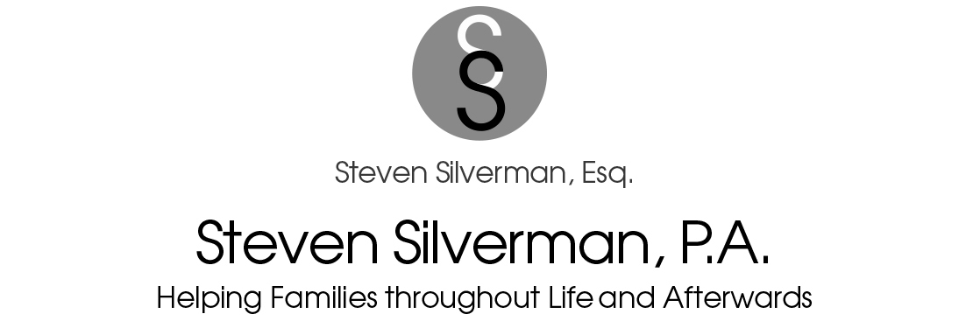

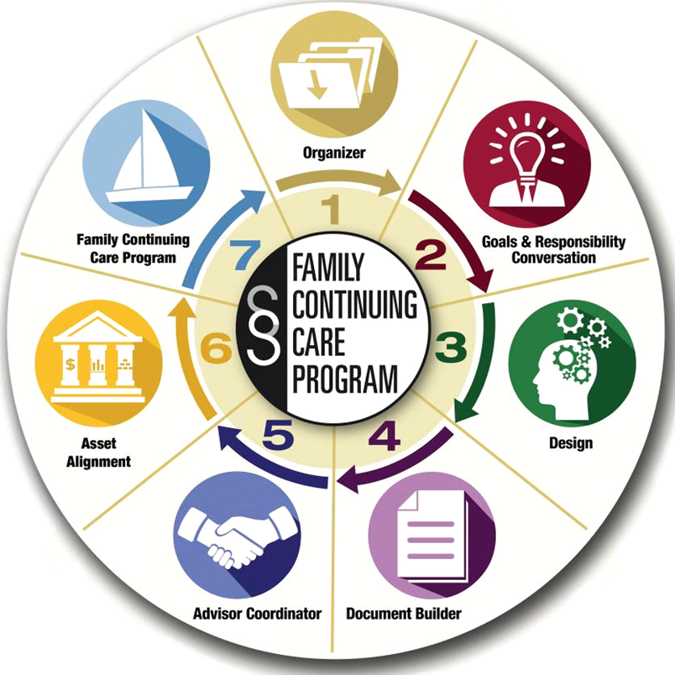

IMPORTANT FAMILY QUESTIONS
Please choose yes or no to the following common estate planning questions. If you choose ‘Yes’ to any of the following statements, please attach a copy of the document related to the question.
Are you (or your spouse/partner) receiving Social Security, disability, or other governmental benefits? ___

Are you (or your spouse/partner) making payments pursuant to a divorce or settlement order? ___

Have you (or your spouse/partner) ever filed federal or state gift tax returns? ___

Have you (or your spouse/partner) completed previous will, trust, or estate planning? ___

Are you (or your spouse/partner) currently the beneficiary of anyone else’s trust? ___

CONCERNS
Please rate the following in importance to you by choosing or writing (High, Some or No Concern) as it applies to you at this time.

Tax Concerns
Estate Taxes. We’ve heard that estate taxes can be as high as 40% of the value of many assets.
We’d like to know how to reduce or eliminate an estate tax liability I might have. ______

Capital Gains Taxes. We have an asset that we’re thinking about selling and we’d like to know how we might reduce or eliminate any capital gains taxes that we might owe. ______

Income Taxes. We have significant income from investment assets, and we’d like to know if there is any way to reduce or eliminate the amount of income taxes we pay. ______

Taxes on Retirement Plans. We have a large IRA and or 401K. We know these assets will be subject to both income tax and estate tax at death. We would like to know how to reduce the 70-90% tax burden on these accounts. ______

Disinheriting Beneficiaries. I would like to know how I can disinherit a beneficiary and/ or any children they may leave. ______

Family Concerns

Custodian of Minor Children. We’re concerned that, if either of us were to die, our children will be placed in the custody of someone other than whom we select. ______

Beneficiaries’ Creditors. We’re that our children or other beneficiaries will lose any family wealth we might leave to them to their creditors, lawsuits, or divorcing spouses. ______

Fiscal Immaturity. We’re concerned that our children or other beneficiaries will lose any family wealth we might leave to them due to their mismanagement of the money. _____

Children-in-Law. We’re concerned about what might happen if a son-in-law or daughter-in-law ever got control over any inheritance we might leave to our children. _____

Mismanagement. We’re concerned that the person(s) in charge of managing our children’s or grandchildren’s inheritance might squander or mismanage the funds. _____

Grandchildren’s Education. We’re concerned that our children might not provide for our grandchildren’s education which is very important to us. _____

Risk of Making Beneficiary Ineligible for Governmental Benefits. We have a beneficiary whom we’d like to benefit in our estate planning who is currently receiving governmental benefits. We are concerned about loss of eligibility if they inherit assets. _____

Spousal Control of My Assets if I Pass First. We would like to know that when one of us passes, our assets are available to the other, but that upon the survivor’s death, the assets pass to our children or other beneficiaries. We would not, for example, want our assets to pass to a future spouse or to any other individual who might influence a spouse/partner. _____

Family Disputes. We are concerned about our beneficiaries commencing lawsuits against each other because they feel they’ve received less than they should have received. _____

Hard-to-Divide Assets. Our assets are comprised significantly because one or more assets are not easily divisible (such as an operating business) and we’re concerned that disputes will arise relating to how the assets might be divided. _____

Values & Virtues. We’re concerned that the inheritance we leave to our beneficiaries might prevent them from being productive citizens and would like to take the necessary steps to prevent that from happening.
_____

Planning for Parents. We’re concerned that our parents will need financial assistance if we were to die prematurely. _____

Disability Concerns

Guardianship. We’re concerned that if we were to become disabled, a guardian would be required so that someone would have the legal ability to make health care and financial decisions for me. I want to avoid a Terri Schiavo situation. _____

HIPAA. Our current planning does not reflect the HIPAA privacy rules, and we’re concerned that if something happened to either of us, health care personnel might not disclose information about us to our loved ones. _____

Disability of Single, Adult Children. We’re concerned that if a single, adult child of ours becomes disables, that we would not have the legal ability to make decisions for that child or be informed about that child’s health situation due to HIPAA privacy rules. _____

Independence. We’re concerned that a long-term disability or the challenges of aging will create an unnecessary burden on our family and/or friends. _____

Creditor Concerns

Frivolous Lawsuits. We’re concerned about our assets being taken through frivolous lawsuits. _____

Nursing Home. We’re concerned about our assets being lost to the nursing home. _____

Creditors of Jointly Owned Property. We have property owned as joint tenants with someone other than each other and we’re concerned that a creditor or that another person could take the entire property.
_____
Post-Death Concerns

Probate. We’re concerned about the unnecessary delays and cost that each of our estates will incur if our assets pass via a probate proceeding. _____

Liability of Executor. We’re concerned that the person we’ve named as one of our executors might be sued by an heir because the Executor did not understand what duties were required of them and what liability they take on for serving as executor. _____

Fire Sale. We’re concerned about our assets having to be sold in a “Fire Sale” to pay estate taxes or to pay debts that we owe. _____

Privacy. We’re concerned that personal matters involving family or finance will become public knowledge.
_____

Business Concerns

Validity of Corporate Shield. We own a corporation, or a limited liability company and we’re concerned that our personal assets may still be exposed to liabilities of the company because we’ve not held company meetings annually, kept minutes, elected officers, etc. _____

Employee Lawsuits. We’re concerned that employees might sue because of an out-of-date or nonexistent employee agreement. _____

Business Succession Plan #1. We’re concerned that our company might falter if either were to die unexpectedly because we don’t currently have a business succession plan. _____

Business Succession Plan #2. We’re concerned that we may pay too much tax when we ultimately sell or transfer ownership of the company. _____

Out-of-Date Buy-Sell Agreement. We have a buy-sell agreement with the other owners of the company in which we’re involved but we have no idea if its up-to-date or if the company will have the funds to buy out our interest if either of us were to die. _____

Giving Concerns

Loss of Privacy. We’re concerned that giving to an organization either now or in the future may compromise our privacy. _____

Support. We’re concerned that those individuals or organizations that currently rely on our financial support will also require this in the future and/or after our deaths. _____

Strategic Giving. We are concerned that we may not be aware of all the possible ways we can financially support our favorite charities without placing our family at an economic disadvantage. _____

Final Distributions. We’re concerned that too much money at either of our deaths will go to the government rather than family or charity. _____

Other Concerns (Please list below):
YOUR GOALS AND OBJECTIVES

It is important that your attorney understand what prompted you to schedule this appointment. What is more important to you? What concerns raise above others? Try to focus on the need for a tool
(trust, will, etc.) but rather the outcomes and goals to be achieved.

GOALS CONSEQUENCES IF GOAL ISN’ACCOMPLAISHED

1. _________________________________ 1. _________________________________

2. _________________________________ 2. _________________________________

3. _________________________________ 3.__________________________________

4. _________________________________ 4. _________________________________

5. _________________________________ 5. _________________________________

